Day 1 Lab Work

1. Write a program to Print Fibonacci Series using recursion.

CODE:

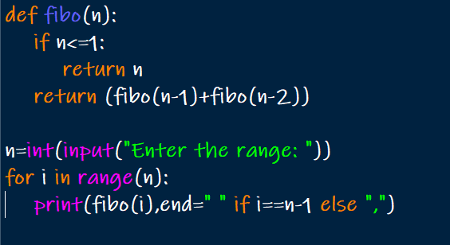

OUTPUT:

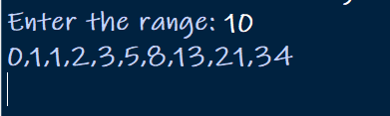

1. Write a program to check the given no is Armstrong or not using recursive function.

CODE:

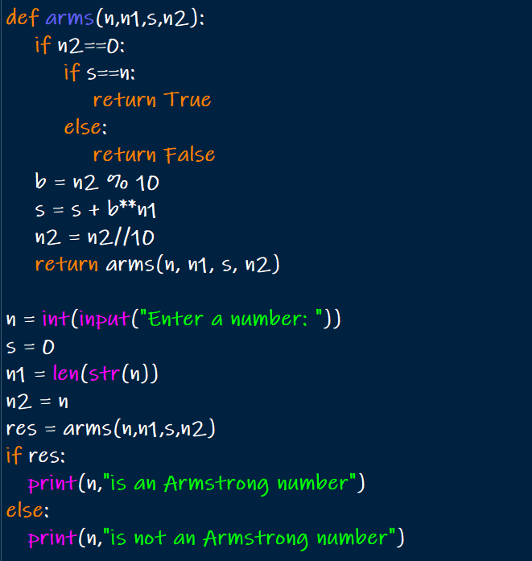

OUTPUT:

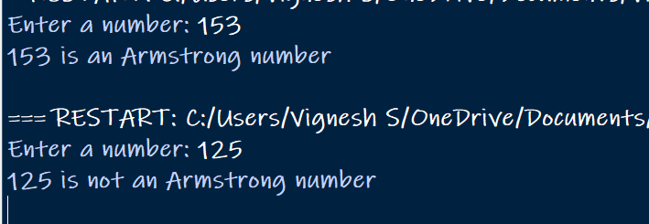

1. Write a program to find the GCD of two numbers using recursive factorization

CODE:

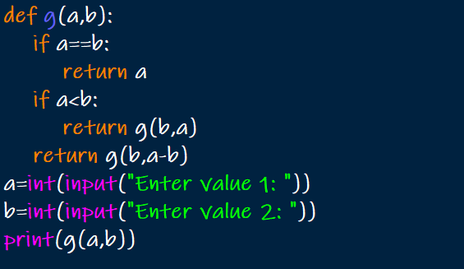

OUTPUT:

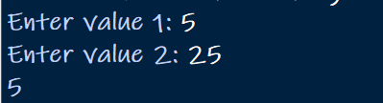

1. Write a program to get the largest element of an array.

CODE:

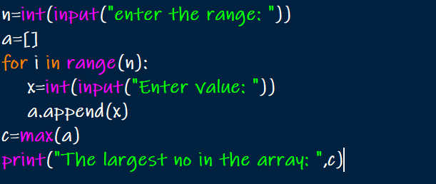

OUTPUT:

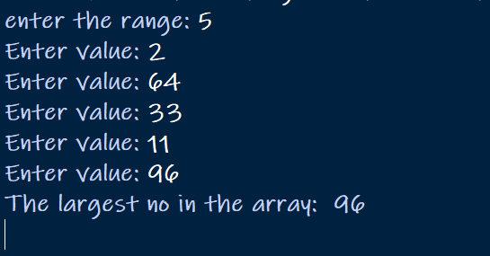

1. Write a program to find the Factorial of a number using recursion

CODE:

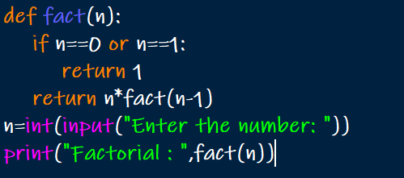

OUTPUT:

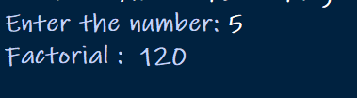

6.Write a program for to copy one string to another using recursion

CODE:

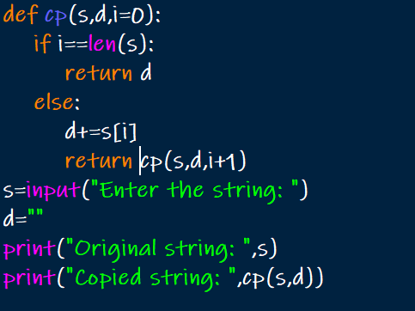

OUTPUT:

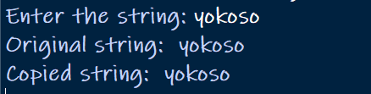

7.Write a program to print the reverse of a string using recursion

CODE:

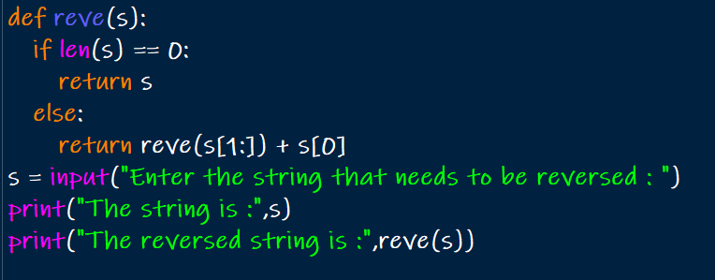

OUTPUT:

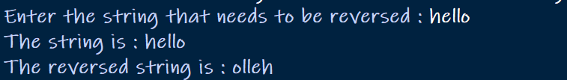

8.Write a program to generate all the prime numbers using recursion

CODE:

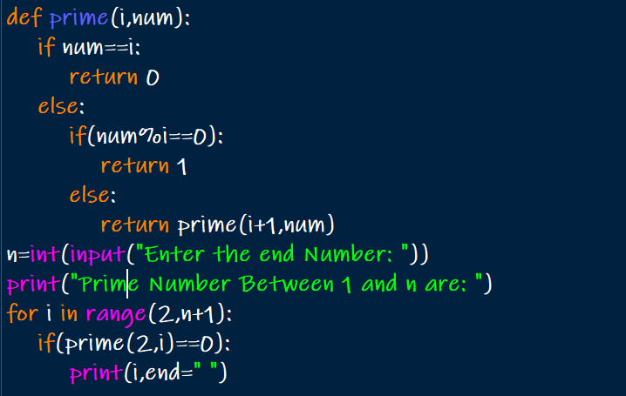

OUTPUT:

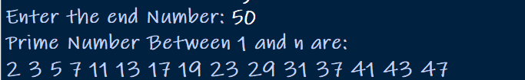

1. Write a program to check a number is a prime number or not using recursion.

CODE:

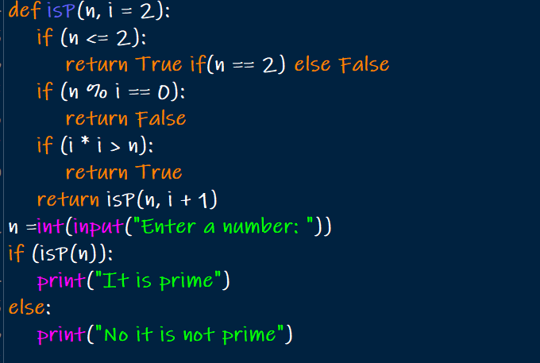

OUTPUT:

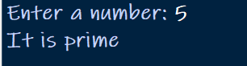

1. Write a program for to check whether a given String is Palindrome or not using recursion

CODE:

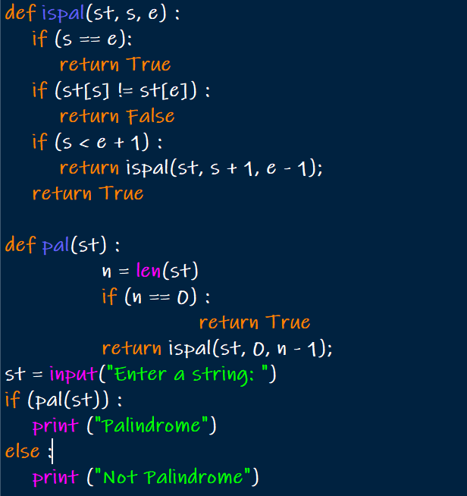

OUTPUT:

